**DAY 1 ( 26-02-2021)**

**Keynote Speakers**

1. **Dr. Xavier Fernando**

Professor

Dept. of Electrical and Computer Engineering,

Ryerson University,

Toronto, Canada

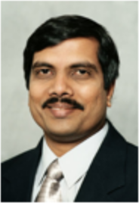

1. **Shailesh Kumar**

Chief Data Scientist,

Centre of Excellence in Artificial Intelligence and Machine Learning,

Reliance Jio,

Hyderabad, India

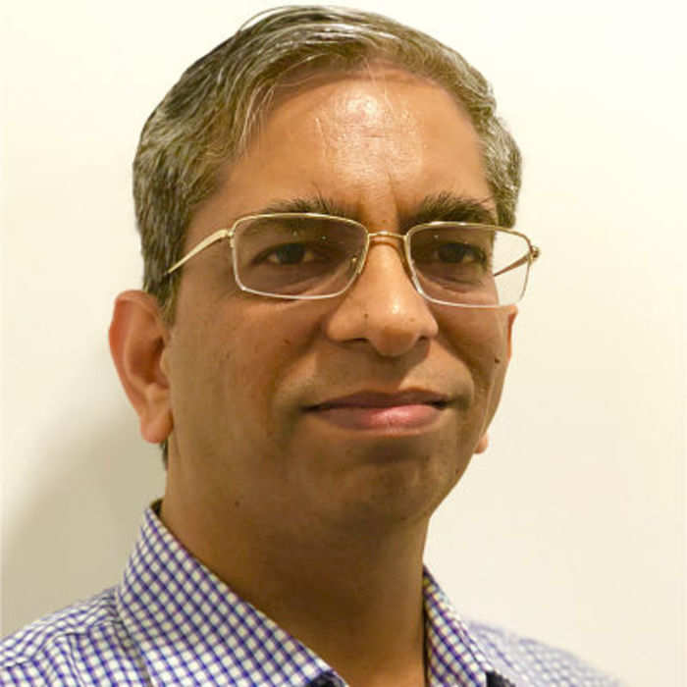

**AI Conclave Panel Speaker**

1. **Mr. Anand Ponnusamy**

Senior Technical Specialist,

Microsoft Corporation,

Chennai, India

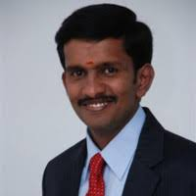

1. **Mr. Dhineshkumar S K**

Project lead,

Lantrasoft Private Limited,

Coimbatore, India

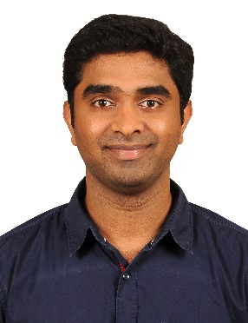

1. **Mr. Muthupavithran Selvam**

Researcher,

De Montfort University (DMU)

Leicester, England, United Kingdom

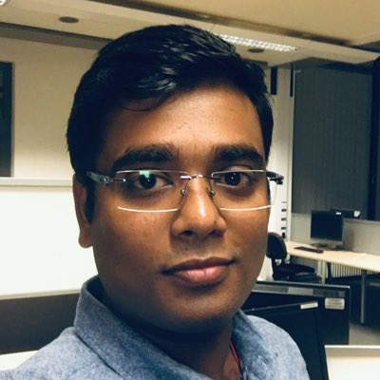

**DAY 2 (26-02-2021)**

**Keynote Speakers**

1. **Onkar Krishna**

Research Associate

NTT Communication Science Laboratories  
NTT Corporation, Japan

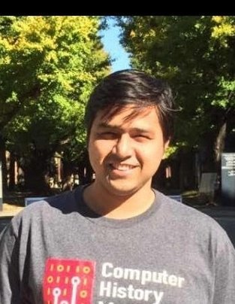

1. Rudradeb Mitra

CEO and founder of Omdena.

United States

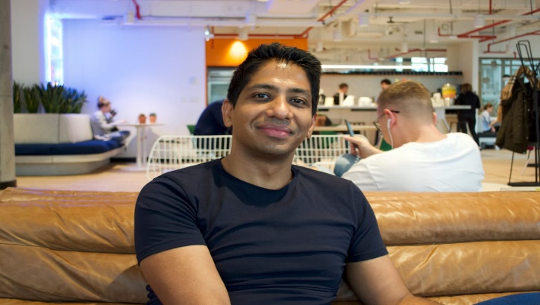

**AI Conclave Panel Speaker**

1. Gopalakrishnan S

Program Champion,

Philips, Bangalore, India

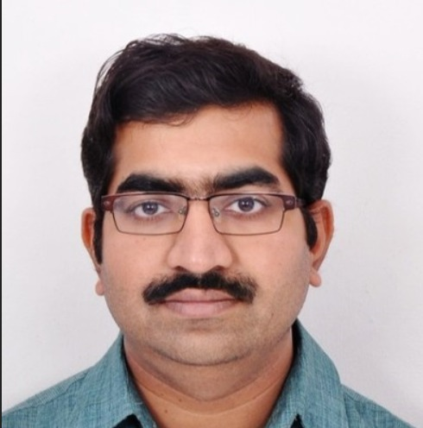

1. Swaminathan K S

Engineer Manager,

Microfocus,

Bangalore, India

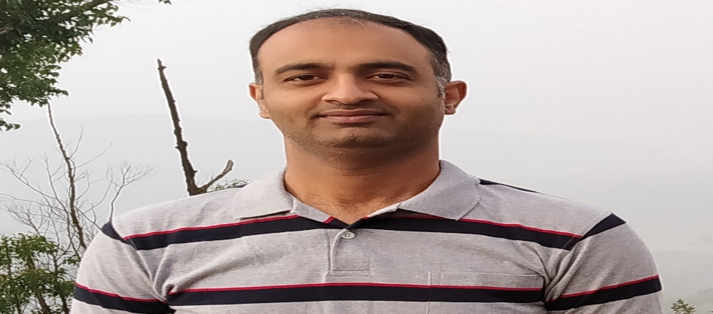

1. Rahul Kishan M

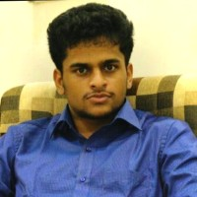

4. Kannann V

Senior Data Engineer

Larsen and Toubro Infotech Ltd

Bangalore

